**Create a Cluster from Admin node**

**Step 1: Create Cluster**

# su - cephadm

$ mkdir ceph-cluster

$ cd ceph-cluster

$ ceph-deploy new cmn01

**If we are getting errors like this, we will follow the below step:-**

[ceph_deploy][ERROR ] RuntimeError: AttributeError: module 'platform' has no attribute 'linux_distribution'

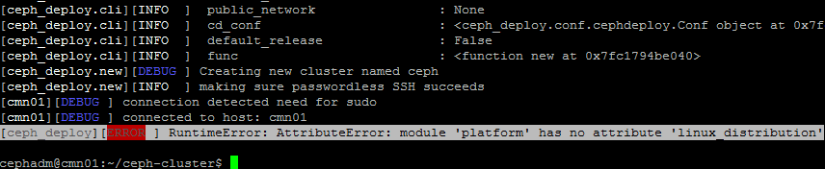

<https://github.com/EdvinasBoguckis/ceph-deploy-fix>

follow the above url to fix the above error

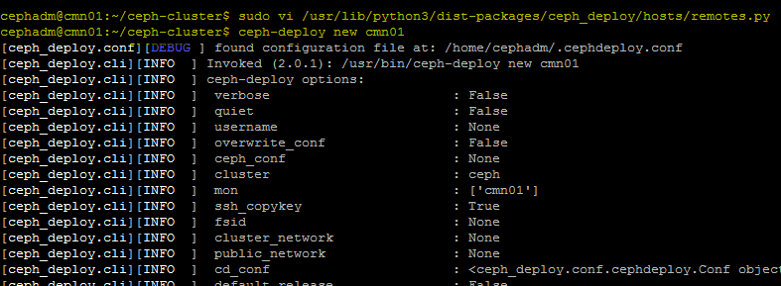

**Step 2: Edit Cluster Conf file**

$  vim ceph.conf

mon_initial_members = cmn01

mon_host = 10.144.163.201

auth_cluster_required = cephx

auth_service_required = cephx

auth_client_required = cephx

public network = 10.144.163.0/24

cluster network = 192.168.22.0/24

**Step 3: Deploy ceph cluster**

$ sudo ceph-deploy install cmn01 cmn02 cmn03 ceph-hdd01 ceph-hdd02 ceph-hdd03 ceph-hdd04 ceph-hdd05 ceph-hdd06 ceph-hdd07 ceph-hdd08 ceph-ssd01 ceph-ssd02 ceph-ssd03 ceph-ssd04 ceph-ssd05 ceph-ssd06

**Step 4: Add the initial monitor(s) and gather the keys:**

$ ceph-deploy mon create-initial

**Step 5: copy the configuration file and admin key to your admin node and your Ceph Nodes**

# sudo ceph-deploy admin cmn01 cmn02 cmn03 ceph-hdd01 ceph-hdd02 ceph-hdd03 ceph-hdd04 ceph-hdd05 ceph-hdd06 ceph-hdd07 ceph-hdd08 ceph-ssd01 ceph-ssd02 ceph-ssd03 ceph-ssd04 ceph-ssd05 ceph-ssd06

**Step 6: Deploy a manager daemon**

$ ceph-deploy mgr create cmn01 cmn02 cmn03

**Step 7: Adding monitor node**

$ ceph-deploy mon add cmn02

$ ceph-deploy mon add cmn03

**Step 8: Check cluster status**

$ ceph -s

$ ceph health detail